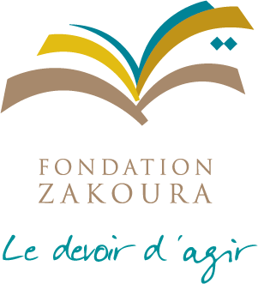

**PARTNERSHIP PROPOSAL:**

**REMEDIAL EDUCATION, EARLY CHILDHOOD PROGRAM, AND LOCAL DIGITAL RURAL MIDDLE SCHOOL**

**July 2024**

# PRESENTATION OF THE ZAKOURA EDUCATION FOUNDATION

1. **The core business of the Zakoura Education Foundation: Human Development through Education**

Recognized as a public utility association, Zakoura Foundation has been working for over 27 years to promote human development through the education of children, the training of young people and the empowerment of women in rural areas. It has developed unique expertise in the deployment of socio-educational projects for rural populations, and benefits from the support and backing of national and international partners.

Since 1997, Zakoura's actions have directly benefited over 1,300,000 people, and thousands of resources have been trained to support this dynamic.

As a driving force behind the transformation of Morocco's educational landscape, the Foundation offers a comprehensive range of services including deployment, training, management and consultancy.

The Foundation's mission is built around **3 key strategic pillars**, positioned across the entire educational value chain: **education from the age of 3** (pre-school, remedial education, traditional and digital Non Formal Education; new-generation middle school)**; employability and empowerment** through training and integration programs, particularly in the education professions, and **strengthening the** Foundation's **ecosystem.**

# Why trust us?

* Over **1,200,000** beneficiaries
* **167,819** children in **3,695** pre-schools
* **917,131** students benefit from the "Mama Tabiaa" environmental education program
* **22,167** students enrolled in **420** non-formal education schools
* **78,937** literate adults
* **4,104** functional literacy beneficiaries
* **14,611** women trained in basic health and hygiene concepts
* **1,503** women benefit from projects supporting women's and children's health and entrepreneurship
* **7,640** women benefit from the parent education program
* **32,762** public school students and SOS Children's Villages children benefiting from remedial education
* **10,247** young people benefit from employability and self-entrepreneurship programs
* **847** associations benefit from capacity-building and empowerment training
* **1,669** children and young people receiving scholarships
* **19** young beneficiaries of the LOCAL DIGITAL RURAL MIDDLE SCHOOL pilot project

# Our commitments:

* **Transparent accounts**: all expenses can be justified at any time, and the Foundation's accounts are certified annually by an external international firm.
* **Regular reporting and field visits**: each project is the subject of an activity report, the frequency of which is defined by the partner, and field visits are possible at any time.
* **Systematic promotion of partners** on:
* ***All corporate communication materials:*** *Website, social networks, annual report, corporate brochure, internal signage*
* ***All******the Foundation's external communication tools:*** *Trade shows, newsletter, canvassing, press relations, press conference, advertising campaign, e-mail campaign, annual partners' reception*
* ***Project-specific communication tools:*** *Project inauguration/closing, major contract renewals, special events, field visits...*

The entire Zakoura Foundation Education partner communication plan is included in this document.

**Our 5 values:**

* Solidarity
* Respect for human dignity
* Equality between men and women
* The demand for quality
* Ethics

**PRESENTATION OF THE LOCAL DIGITAL RURAL MIDDLE SCHOOL**

# PROGRAM PRESENTATION

In order to respond to the problems of access to secondary schooling in rural areas, while adapting to changes in the national and international context, the Zakoura Foundation has developed a model for a local digital secondary school.

The modus operandi of this project is based on a dematerialized middle school with a remote teaching staff and a Local Digital Rural Middle School located in a douar where there was previously no middle school. This means that the best teachers can be mobilized remotely.

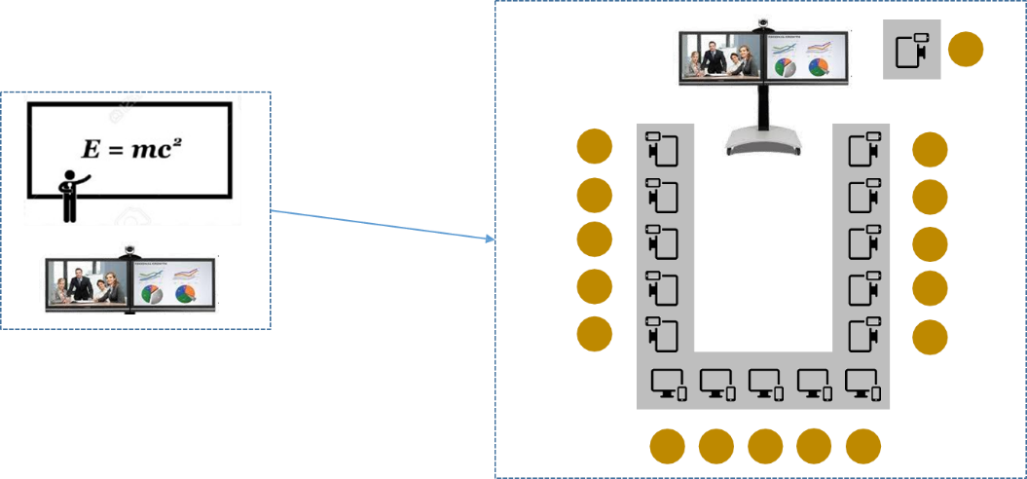

**LOCAL DIGITAL RURAL MIDDLE SCHOOL:**

## Target

15 to 20 students aged 12 to 16 who have dropped out of school and obtained their elementary school leaving certificate, and secondary school dropouts.

## Objectives

* Providing local middle school education for students from disadvantaged backgrounds
* Creation of the local digital middle school and establishment of the steering committee and operational committee
* Design of a pedagogical model adapted to Local Digital Rural Middle School;
* Training and support for facilitators and educators;
* Set up a permanent monitoring and evaluation system for the project;
* Analysis of the existing situation to set up a project sustainability system.

## Terms and conditions

Students' timetables will be defined in consultation with parents, following the example of the Foundation's non-formal education schools, in order to take into account families' day-to-day constraints.

The school rhythm will therefore be as follows

* Courses 11 months a year
* Adjusted timetable
* 6 days a week

Classes are multi-level and multi-age. They welcome students who have passed their elementary school leaving exams, as well as school drop-outs.

* + Teaching of 11 subjects (mathematics, physics/chemistry, natural sciences, French, Arabic, Islamic education, history/geography, sports, arts, technology, languages)
  + Curriculum and textbooks identical to those of the national program
  + 3 years of middle school
  + A distance learning team of teachers (one per subject).
  + Personal development courses will also be offered, as well as guidance sessions to help students make the transition to further study.

## The pedagogical model 1- The courses

Students have access to interactive online courses, a digital platform, recorded capsules for later viewing or academic remediation, as well as personalized support provided by a facilitator.

In addition to the basic cycle based on the formal curriculum (7 teachers, 1 per subject), the learning areas are defined in collaboration with the Curriculum Department and AREF, and in line with the existing middle school curriculum. Other activities are also deployed, such as soft skills and life skills training.

## Meeting with parents

Aimed at involving parents in their children's schooling and making them aware of the need for regular attendance at school, monthly meetings are organized locally by the facilitator, with the students' parents, sometimes in the presence of the referent or a manager from head office.

# RESOURCES AND IMPLEMENTATION STAGES:

**Human resources:**

**In the field,** the following team is in place:

* **A facilitator** is mobilized for each group of beneficiaries and each site, and is present at all sessions to accompany the students and act as a point of contact between them and the distance learning team, which is essentially made up of teachers.
* **A local supervisor** completes the system: he or she is responsible for monitoring the activities deployed to ensure positive and constructive interactions between the school and the rest of the local community.
* **A team based at head office** monitors activities and supervises and trains the entire field team:

## Operational management:

Operational management will ensure that activities run smoothly and supervise field teams. It will also carry out monitoring visits, which may trigger specific action plans depending on the results observed (e.g. mobilization campaign in the event of repeated absences). She will also be responsible for information processing and performance management, monitoring and analyzing indicators by activity and program, and drawing up monthly action plans.

## Training direction:

This department will be involved in the training of the animator and supervisor, and in the pedagogical follow-up of the programs. It will also carry out follow-up visits and may provide support or additional training depending on observed needs.

## Partnership Department:

The partnership department will send half-yearly activity reports and annual financial reports to the partner, and will also respond to any specific requests from the partner.

## Administrative and Financial Management:

She will be responsible for the administrative and financial follow-up of the project.

# Field staff training

3 types of training related to the two project activities are followed by both the animators and the local coordinator:

* **Initial training**: A 16-day training course will be given locally to train the project team;
* **A further 6 days of training** will be dedicated to extracurricular activities.
* **A monthly training** session given by the local coordinator, or/and a head office manager or an external trainer, to the facilitators to discuss the pedagogical problems encountered during the month.

We will also be offering dedicated training courses for our public school partners, depending on the budget available.

# Equipment:

Implementing the project's activities requires fitting out the classroom and teacher's cubicle with appropriate digital equipment, as well as the room's equipment and school supplies.